MILLENNIUM COMPANION, INC.

9700 North Rodney Parham
Suite D
501.414.8699 office * 501.414.9699 fax



We Are the Solution for Your In Home Non-Medical Care Needs!

Just call… We Can Help!

mchomecare.com

MILLENNIUM COMPANION, INC.
9700 North Rodney Parham
Suite D
501.414.8699 office * 501.414.9699 fax

HOME COMPANION/PERSONAL CARE SERVICES
- Personal Care (Grooming, Bathing)
- Meals (Light Meals, Feeding)
- Assisting with Mobility
- Reminders (Meds, Appts, Routines)
- Entertainment (Arts & Crafts, Games)
- Incontinent Care
- Light House Keeping
- Fall Prevention
- Light Exercises
- New & Expectant Parents

WHY CHOOSE MILLENNIUM COMPANION?
- 24 hour services, including all holidays and weekends
- A level of care that meets and exceeds the industry standards
- Professional healthcare providers
- Regular assessments by management to ensure client satisfaction
- Flexible payment options

mchomecare.com

MILLENNIUM COMPANION, INC.
9700 North Rodney Parham
Suite D
501.414.8699 office * 501.414.9699 fax

We Accept Medicaid and AR Choices, as well as VA clients!

WHY IS THAT IMPORTANT?
- Employees are held to a higher standard
- An oversight committee which guarantees efficiency
- Structure and Organization
- Dedication to the industry
- In depth background checks on all employees and contractors



mchomecare.com

MILLENNIUM COMPANION, INC.
9700 North Rodney Parham
Suite D
501.414.8699 office * 501.414.9699 fax

MILLENNIUM COMPANION AT A GLANCE…

We design our Companion Services to keep you at your maximum level of function, prevent institutionalization, and to keep the family unit intact, all while reducing caregiver strain. We are NOT a mere sitting agency! Each patient has a clear Plan of Care designed by our on staff Registered Nurse, with detailed responsibilities for the care attendant, which must be completed at each visit.

We have excellent documentation to insure that the tasks were completed, and done to the patient’s satisfaction.

We pride ourselves on our dedication to your functional status. No task is too small; no disability is too great! Whatever the case may be, we WILL rise to the occasion!
One extra detail that differentiates us from the others is that we can be at your avail within minutes of your initial call. We have a substantially large, credentialed, trained staff ready to work with you at your earliest convenience. Just call… we can help!

mchomecare.com
MILLENNIUM COMPANION, INC.
9700 North Rodney Parham
Suite D
501.414.8699 office * 501.414.9699 fax

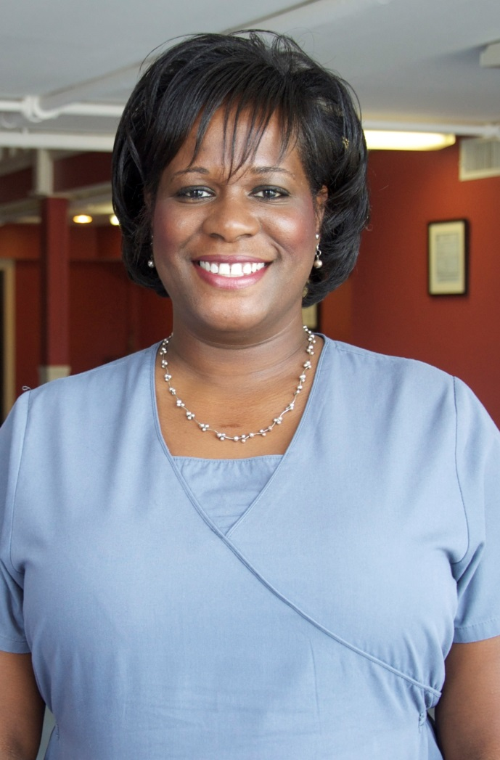

Shay Stevens, Program Director

Feel free to stop by the office at any time to discuss the details of the care you or your loved one’s needs.
mchomecare.com

MILLENNIUM COMPANION, INC.
9700 North Rodney Parham
Suite D
501.414.8699 office * 501.414.9699 fax

OUR RANGE OF SERVICES
- Dementia
- Multiple Sclerosis
- Developmental Disorders
- Paralysis
- High Risk Pregnancies
- Post Surgical Procedures
- Cerebral Palsy
- Auto Immune Diseases
- Post Stroke/Heart Attacks
- Spinal Cord Injuries

Just call… we can help!

We will design a Plan of Care, with the help of the patient and family, around your specific needs. We hold your functional status and level of independence in high regards.

- Flexible rates per hour, well BELOW industry standards
- Credits for missed visits, on some occasions
- Reduced rates for overnight hours and weekend hours
- Free Assessments and visits
- Discounts for referrals available
mchomecare.com

